

**实 验 报 告**

|  |  |  |
| --- | --- | --- |
| **课程名称**： WEB应用开发技术 | **任课教师：** 雷 宇 | **实验日期**： 2021.5.6 |
| **班 级**： 信1901-4 | **姓 名**： 闫竞存 | **学 号**： 20194127 |

**实验项目名称：实验一 客户端脚本编程**

**本次实验网页已经部署到服务器：**

[**http://39.103.184.190:8888/learn/weblabs/lab01/**](http://39.103.184.190:8888/learn/weblabs/lab01/)

**一、实验目的**

通过设计一个个人主页网站，学习常用的HTML标记，学习使用CSS对页面进行美化，掌握JavaScript的语法和常用的浏览器对象，初步学会使用Eclipse创建网站和编辑网页的方法。

**二、实验内容和要求**

1. 自己设计网页内容，做一张展示自己网页。要求展示的主要内容有：基本资料、学习经历、所得奖励、最新动态等。
2. 在网页的合适位置加入一些JavaScript特效，例如显示当前时间、图片定时切换、文本自动滚屏等。
3. 将网页源代码和浏览器截图写入实验报告并提交。

**三、实验步骤**

1. 部署tomcat服务器。在tomcat官网下载tomcat的压缩包并解压。

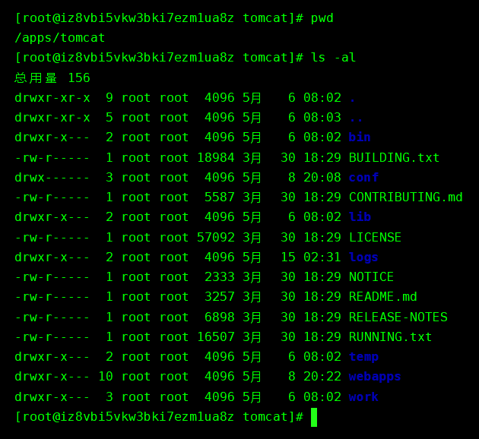

2. 编写个人主页

代码：

|  |
| --- |
| <!—index.html -->  <!DOCTYPE *html*>  <html>  <head>      <meta *http-equiv*="Content-Type" *content*="text/html; charset=UTF-8">      <title>Lab01</title>      <link *href*="./css/move.css" *rel*="stylesheet" *type*="text/css">      <link *rel*="stylesheet" *type*="text/css" *href*="./css/timeline.css"/>      <link *rel*="stylesheet" *type*="text/css" *href*="./css/personalInfo.css">      <script *src*="https://cdn.bootcdn.net/ajax/libs/jquery/1.9.0/jquery.min.js"></script>      <body>  *<!-- 滑动下拉框 -->*          <div *class*="num_box" *style*="bottom: 0px;">              <div *class*="num" *id*="num_0">                  <div *class*="title" *style*="margin-left: 30%;">                      <div *class*="subject-title">Web应用开发技术-LAB01</div>                      <div *class*="edit-by">信1901-4 闫竞存 20194127</div>                  </div>              </div>              <div *class*="num" *id*="num_1">                  <div *class*="personal-info" *style*="margin-left: 10%;">  *<!-- 标题 -->*                      <div *class*="person-info-title">Personal Resume</div>  *<!-- 个人信息 -->*                      <div *class*="personal-info-content">                          <table>                              <tr>                                  <td>姓名</td>                                  <td>闫竞存</td>                              </tr>                              <tr>                                  <td>性别</td>                                  <td>男</td>                              </tr>                              <tr>                                  <td>爱好</td>                                  <td>计算机科学/Java/Python</td>                              </tr>                              <tr>                                  <td>座右铭</td>                                  <td>十年饮冰，难凉热血。</td>                              </tr>                              <tr>                                  <td>主要成就</td>                                  <td>                                      <ul>                                          <li>2020.09 通过英语四级</li>                                          <li>2020.12 通过英语六级</li>                                          <li>2021.04 蓝桥杯省赛二等奖</li>                                          <li>两次优秀学生奖学金</li>                                          <li>在博客园发表技术博客数十篇并获得10k+访问量</li>                                          <li>Github一年内提交320次(截止2021.5.14)</li>                                      </ul>                                  </td>                              </tr>                          </table>                          <div *class*="page-index">2/3</div>                      </div>                  </div>              </div>              <div *class*="num" *id*="num_2">                  <div *class*="time-line" *style*="margin-left: 10%;">                      <div *class*="time-line-title">Time Line</div>  *<!-- 时间线 -->*                      <div *class*="segment-line"></div>  *<!-- 分成两半，左边和右边 -->*  *<!-- 左边的时间线 -->*                      <div *class*="time-line-content time-line-content-left">  *<!-- 年份 -->*                          <div *class*="year-title">2021年</div>                          <div *class*="segment-line"></div>                          <ul *class*="year-item">  *<!-- 每个月学了点啥 -->*                              <li *class*="clearfix">                                  <div *class*="month-item">                                      <div *class*="month-title">至今</div><div *class*="month-learn">SpringBoot&Vue</div>                                  </div>                              </li>                              <li *class*="clearfix">                                  <div *class*="month-item">                                      <div *class*="month-title">4月</div><div *class*="month-learn">个人博客【HTML/CSS/JQ/MySQL/SSM】(11K行)</div>                                  </div>                              </li>                              <li *class*="clearfix">                                  <div *class*="month-item">                                      <div *class*="month-title">3月</div><div *class*="month-learn">SpringMVC & MyBatis</div>                                  </div>                              </li>                              <li *class*="clearfix">                                  <div *class*="month-item">                                      <div *class*="month-title">2月</div><div *class*="month-learn">JQuery & Ajax, Spring</div>                                  </div>                              </li>                              <li *class*="clearfix">                                  <div *class*="month-item">                                      <div *class*="month-title">1月</div><div *class*="month-learn">员工管理系统【JSP/CSS/Servlet/MySQL】(1k行)</div>                                  </div>                              </li>                              <li *class*="clearfix">                                  <div *class*="month-item">                                      <div *class*="month-title">1月</div><div *class*="month-learn">JSP & Servlet</div>                                  </div>                              </li>                          </ul>    *<!-- 年份 -->*                          <div *class*="year-title">2020年</div>                          <div *class*="segment-line"></div>                          <div *class*="year-item">                              <ul>                                  <li *class*="clearfix">                                      <div *class*="month-item">                                          <div *class*="month-title">12月</div><div *class*="month-learn">图书馆管理系统【Oracle/JavaSE/JavaSwing】(4K行)</div>                                      </div>                                  </li>                                  <li *class*="clearfix">                                      <div *class*="month-item">                                          <div *class*="month-title">11月</div><div *class*="month-learn">JavaScript</div>                                      </div>                                  </li>                              </ul>                          </div>                      </div>                      <div *class*="time-line-content time-line-content-right">  *<!-- 每个月学了点啥 -->*                          <div *class*="year-item">                              <ul>                                  <li *class*="clearfix">                                      <div *class*="month-item">                                          <div *class*="month-title">10月</div><div *class*="month-learn">Python爬虫(Scrapy/Selenium)</div>                                      </div>                                  </li>                                  <li *class*="clearfix">                                      <div *class*="month-item">                                          <div *class*="month-title">9月</div><div *class*="month-learn">Oracle Database</div>                                      </div>                                  </li>                                  <li *class*="clearfix">                                      <div *class*="month-item">                                          <div *class*="month-title">8月</div><div *class*="month-learn">MySQL</div>                                      </div>                                  </li>                                  <li *class*="clearfix">                                      <div *class*="month-item">                                          <div *class*="month-title">7月</div><div *class*="month-learn">HTML&CSS</div>                                      </div>                                  </li>                                  <li *class*="clearfix">                                      <div *class*="month-item">                                          <div *class*="month-title">6月</div><div *class*="month-learn">JavaSE</div>                                      </div>                                  </li>                                  <li *class*="clearfix">                                      <div *class*="month-item">                                          <div *class*="month-title">4月</div><div *class*="month-learn">Data Structure</div>                                      </div>                                  </li>                                  <li *class*="clearfix">                                      <div *class*="month-item">                                          <div *class*="month-title">3月</div><div *class*="month-learn">2048小游戏【C++/Command Line】(1k行)</div>                                      </div>                                  </li>                                  <li *class*="clearfix">                                      <div *class*="month-item">                                          <div *class*="month-title">2月</div><div *class*="month-learn">C++</div>                                      </div>                                  </li>                              </ul>                          </div>  *<!-- 年份 -->*                          <div *class*="year-title">2019年</div>                          <div *class*="segment-line"></div>                          <div *class*="year-item">                              <ul>                                  <li *class*="clearfix">                                      <div *class*="month-item">                                          <div *class*="month-title">10月</div><div *class*="month-learn">C语言</div>                                      </div>                                  </li>                              </ul>                          </div>                          <div *class*="page-index page-index-2">3/3</div>                      </div>                  </div>              </div>          </div>  *<!-- 以下内容是不可见的 -->*  *<!-- 接受鼠标滚轮下拉的input -->*          <input *type*="hidden" *value*="0" *class*="ddw">          <input *type*="hidden" *value*="0" *class*="ddw2">  *<!-- 引入move效果和鼠标滚轮js -->*          <script *src*="./js/move.js"></script>          <script *src*="./js/jquery.mousewheel.js"></script>      </body>  </html> |

|  |
| --- |
| *// ./js/move.js*  *// 屏幕标号的负值（层数）*  **$**('.ddw').**val**(0);  *// 当前还能不能滑动, 0表示能*  **$**('.ddw2').**val**(0);  */\**  *setTimeout(function, time) 一段时间之后执行某函数*  *stop() 函数，停止目前在指定元素上运行的所有动画*  *animate() 函数，创建自定义动画*  *\*/*  **setTimeout**(function(){  *// 找到第一个num类的元素，找到其中的p标签，停止在上面运行的所有动画，执行自定义动画*  *// 自定义动画：500ms 内，让指定的元素运动到距离顶端 50% 的地方*  **$**('.num').**eq**(0).**find**('.title').**stop**().**animate**({'top':'40%'},500)  *// 250 毫秒后执行*      }, 250);  *// 页面加载完毕之后执行*  **$**(function(){  **$**('.num_box').**mousewheel**(function(event, delta) {  *// canSlide 表示当前还能不能滑动*          var canSlide =**$**('.ddw2').**val**();          console.**log**("canSlide = " + canSlide);          if (canSlide == 1){              return;          }  *// delta 表示鼠标滚轮方向， 1表示向上滚动，-1表示向下滚动*  **doActive**(delta);      });  });  *// 函数的参数：鼠标滚轮方向*  *// 1表示向上 -1表示向下*  function **doActive**(a){  *// 从这里可以看出 ddw 是当前距离页面顶部的层数*      var nagtiveNumIndex =**$**('.ddw').**val**();  *// 当前距离页面顶部的层数，也就是屏幕标号的 负值*      b = **parseInt**(nagtiveNumIndex);  *// 屏的数量*      AllScreens = **$**('.num').length;      if(a < 0){  *// 如果向下滚*          if(-b == AllScreens - 1){  *// 滚到底了，直接返回*              return;          }  *// 没滚到底*          b -= 1;  **$**('.ddw2').**val**(1);      }else if(a > 0){  *// 如果向上滚*          if(-b == 0){  *// 滚到顶了*              return;          }  *// 没滚到顶*          b += 1;  **$**('.ddw2').**val**(1);      }  *// 此时 b 已经变成了 -> 当前滑到了哪块屏幕上。*      if(-b == 0){  *// 应该在首页屏幕*  **$**('.num').**eq**(1).**find**('div').**animate**({'top':'0'},500);  **setTimeout**(function(){  **$**('.num').**eq**(0).**find**('.title').**animate**({'top':'40%'},500);          },1300);      }else if(-b == 1){  **$**('.num').**eq**(0).**find**('.title').**animate**({'top':'0'},500);  **$**('.num').**eq**(2).**find**('div').**animate**({'top':'0'},500);  **setTimeout**(function(){  **$**('.num').**eq**(1).**find**('.personal-info').**animate**({'top':'10%'},500);          },1300);      }else if(-b == 2){  **$**('.num').**eq**(1).**find**('div').**animate**({'top':'0'},500);  **setTimeout**(function(){  **$**('.num').**eq**(2).**find**('div').**animate**({'top':'10%'},500);          },1300);      }  *// 当前所在层数*  **$**('.ddw').**val**(b);  *// 屏幕高度*      var single_hh = **$**(window).**height**();  *// 当前应该在的屏幕高度 = 页面高度 * 层数*      click_hh =- single_hh * b;  **$**('.num_box').**animate**({'bottom': click_hh}, 1000);  **setTimeout**(function(){  **$**('.ddw2').**val**(0);      },1400);  }  *// 调整屏幕大小（让他能全屏显示）*  function **formatScreenSize**(){      var single_hh = **$**(window).**height**();      var single_ww = **$**(window).**width**();  **$**('.num').**height**(single_hh);  **$**('.num').**width**(single_ww);  }  **formatScreenSize**();  *// 调整屏幕大小*  **$**(window).**resize**(function(){      if (typeof indexSlides != 'undefined' && indexSlides.reformat)          indexSlides.**reformat**();  **formatScreenSize**();  }); |

|  |
| --- |
| // ./css/move.css  @charset "utf-8";  html{       overflow:hidden;  }  div{       -webkit-user-select:none;       -moz-user-select:none;       -ms-user-select:none;       user-select:none;  }  html,body,div,dl,dt,dd,ul,ol,li,h1,h2,h3,h4,h5,h6,pre,form,fieldset,input,textarea,p,blockquote,th,td{       margin:0;padding:0;  }  body{       font-family:"微软雅黑";       font-size:12px;       color:#000000;       word-wrap:break-word;       behavior:**url**("csshover.htc");       overflow:hidden;  }  button,input,select,textarea{       font:12px/1.5  Arial, "宋体", Helvetica,  Verdana, sans-serif;       word-wrap:break-word;       color:#565756;  }  ul,li{       list-style:none;       margin:0;       padding:0;  }  h1, h2, h3, h4, h5, h6{       font-weight:normal;       font-size:100%;  }  img{       border:none;       border:0;       vertical-align:middle;  }  a{       text-decoration:none;       outline:none;  }  p{       margin:0;       padding:0;  }  input,select,textarea{       vertical-align:middle;       *font-size:100%;  }  input{       margin:0;       outline:none;       padding:0;  }  input::-ms-clear{       display:none;  }  .clearfix:after{       content:".";       display:block;       height:0;       clear:both;       visibility:hidden;  }  .clearfix{       *zoom:1  }  .ddw{       position:absolute;       left:0;       top:0;       color:#000;       font-size:16px       ;z-index:9999;  }  .ddw2{       position:absolute;       left:20px;       top:0;       color:#000;       font-size:16px;       z-index:9999;  }  .num_box{       position:relative;  }  .num{       color:#fff;       font-size:50px;       width:100%;  */* text-align:center; */*       position:relative;  }  .num>div{       position:absolute;       top:0;       margin: auto;  }  #num_0{       background-image: **url**("../img/002.jpg");       background-position: center;       background-size: auto;  }  #num_1{       background-image: **url**("../img/001.jpg");       background-position: center;       background-size: auto;    }  #num_2{       background-image: **url**("../img/003.jpg");       background-position: center;       background-size: auto;  }  .title{       width: 40%;       position: initial;  }  .title .subject-title{       text-decoration: underline;  }  .title .edit-by{       font-size: 20px;        text-align: center;  }  .page-index{       margin-top: 20px;       position: static;       font-size: 20px;       float: right;       opacity: 0.5;  }  .page-index-2{       margint-top:40px;  } |

|  |
| --- |
| // ./css/personalInfo.css  .person-info-title{      margin-top: 10px;  }  table{      margin:0 10%;      margin-top: 20px;      width: 80%;      font-size: 20px;      border-collapse: collapse;  }  table tr td{      padding: 15px 0;      width: auto;      border-bottom: #000000 1px solid;      border-top: #000000 1px solid;  }  table tr li{      margin: 7px 0;  }  table tr:hover{      background-color: #d2d3d2;  } |

|  |
| --- |
| // ./css/timeline.css  */* 透明遮罩 */*  .personal-info,.time-line{       width: 80%;       height: 80%;       background-color: aliceblue;       opacity: 0.7;       margin: auto;       color: black;       text-align: center;  }  .segment-line{      height: 1px;      width: 80%;      background-color: #545356;      opacity: 0.5;      margin: 15px 10%;  }  */* 年份卡片 */*  .year-item{      border-radius: 20px;      width: 100%;  }  */* Time Line */*  .time-line-title{      margin-top: 10px;      height: 12%;  }  */* 左右内容区 */*  .time-line-content{      width: 46%;      height: 80%;      margin-left: 2%;  }  */* 右半部分内容区 */*  .time-line-content-right{      float: right;  }  */* 左半部分内容区 */*  .time-line-content-left{      float: left;  }  */* 2021年 字样 */*  .time-line-content .year-title{      font-size: 30px;    }  */* li节点 */*  .year-item li{      width: 100%;      font-size: 22px;      margin: 10px auto;      border-radius: 5px;  }  .year-item li:hover{      background-color: #c4c7c8;  }  .year-item .month-item{      float: left;  }  */* 几月 */*  .month-item .month-title{      font-weight: 600;      display: inline-block;  }  */* 学了啥 */*  .month-item .month-learn{      margin-left: 10px;      display: inline-block;      font-size: 20px;  } |

3.程序截图

**由于截图原因，网页中的动画无法显示**

完整内容可以访问 [**http://39.103.184.190:8888/learn/weblabs/lab01/**](http://39.103.184.190:8888/learn/weblabs/lab01/) 进行查看

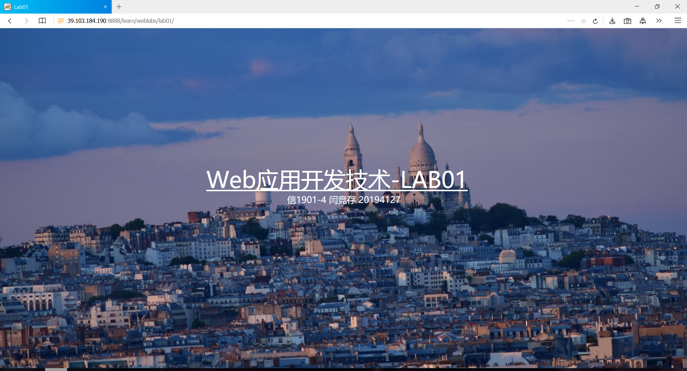

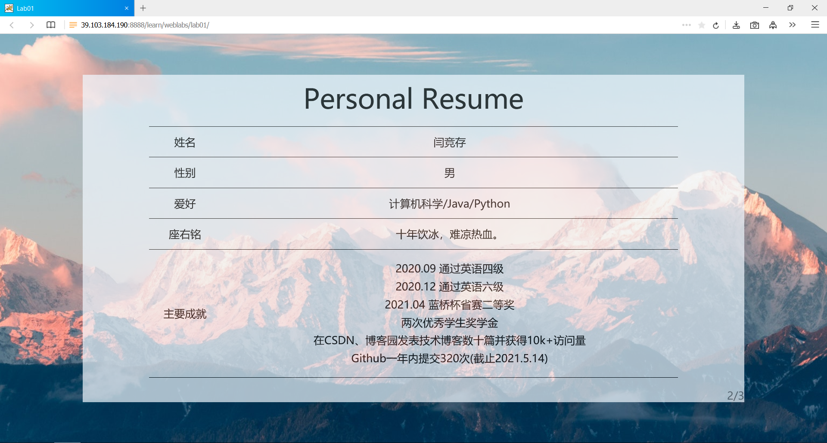

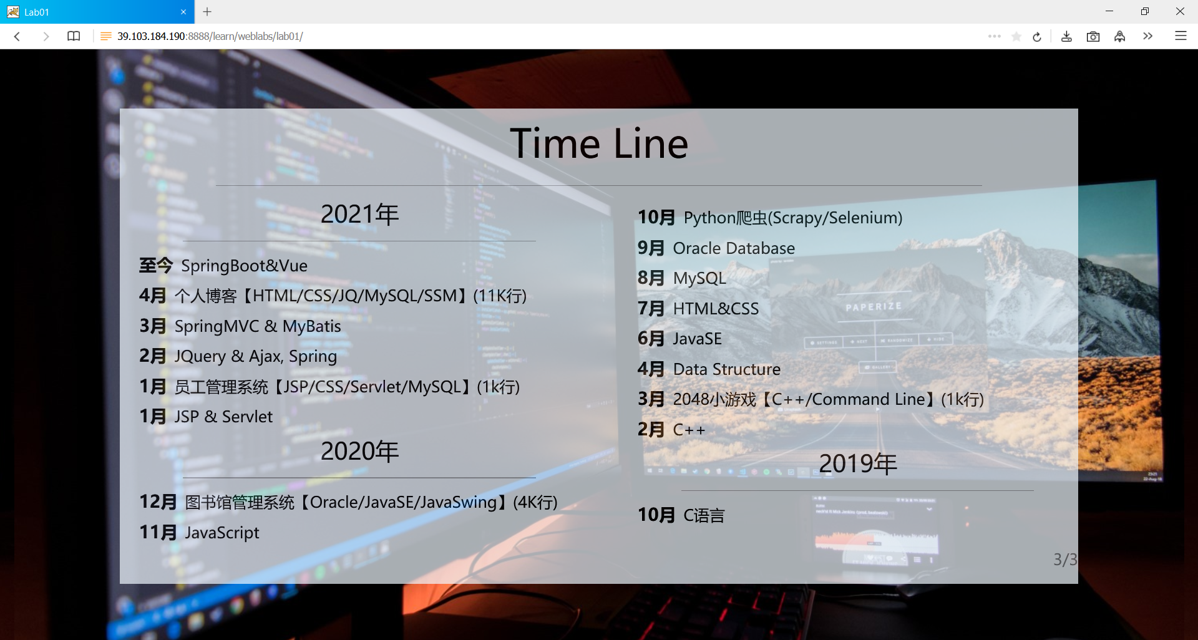

**四、心得体会**

整个网页写下来断断续续用了5天时间，700行左右，用了开源的 mousewheel.js 和jquery。因为还有其他事情要忙，所以没有时间再做更多的改进或者适配，所以不同的浏览器看起来的效果可能会不太一样。

我当时学前端三大件的时候是大一的暑假，当时正准备四六级考试，时间比较紧，所以没有做很大的前端项目练手，几个月没碰前端，有些手生，写网页的时候也是一边查一边写的，好在及时写完了。

我从这个项目中学到的东西，应该是关于布局和不同标签的使用，以前我使用标签的原则是“能用div就不用其他的”，图片、列表等，都是用div标签，然后用类区分。在本次项目中我感觉，利用好不同标签的语义和属性，可以极大减少开发难度，并且能让选择器变得易于使用。

**五、自我评价**

**分数自评**

|  |  |  |
| --- | --- | --- |
| **序号** | **评分标准** | **总分** |
| 1 | 使用HTML+CSS+JavaScript完成了展示自己信息的主页 | 6 |
| 2 | 使用了图片、表格、列表、段落等多种HTML元素 | 2 |
| 3 | 添加了JavaScript代码 | 1 |
| 4 | 页面美观 | 1 |
| 合计 |  | 10 |
| 自评分 |  | 10 |